2.1 Assumption and justifications

2.2 Inputs

variable*10 (待建表)

Part 3 Methodology: Problem 1

3.1 Overview

图

Aim: Our aim is to build the algorithm that agrees with historical changes and precisely simulate the changes in CO2 concentration, while taking multiple factors into consideration.

Method: We picked 10 major relevant factors, including global population, urban population, GDP, Industry Added Value, Agriculture Added Value, percentage of energy produced from fossil fuel, percentage of energy produced from new resources, GDP per kilogram of petroleum, forest area and farmland area. Based on the records from 1960 to 2021, we fit historical data into ten curves to predict future changes. After evaluating and comparing the weights of the factors, ten curves are then merged into a single curve reflecting future trends of CO2 levels. We selected three approaches to fit past records most accurately. We made our predictions based on the three curves.

3.2 Factor Selection and Projection

In order to take the most aspects of influential factors that affects the changes in CO2 concentration in the atmosphere into consideration, we analyzed statistics released by official institutions available online, for instance the World Bank and the UN Population Division, to identify the data representing the widest range of subordinate fields while avoiding ？. Focusing on indirect data influencing from direct CO2 production helps us extend our vision and avoid wasting time analyzing the sources that had been recorded and summarized previous to our work. For example, urban population represents various CO2 emitters from human to gasoline, for it uncovers the number of petrol-powered vehicles and thus the amount of gasoline needed.

We divided selected statistics into three parts: economic data (GDP, Industry Added Value, Agriculture Added Value and GDP per kilo of petroleum), geographical data (global population, city population, forest area and farming area) and sources of energy (energy produced from fossil fuel and energy produced from new resources).

3.2.1 Global Population and Urban Population Projection

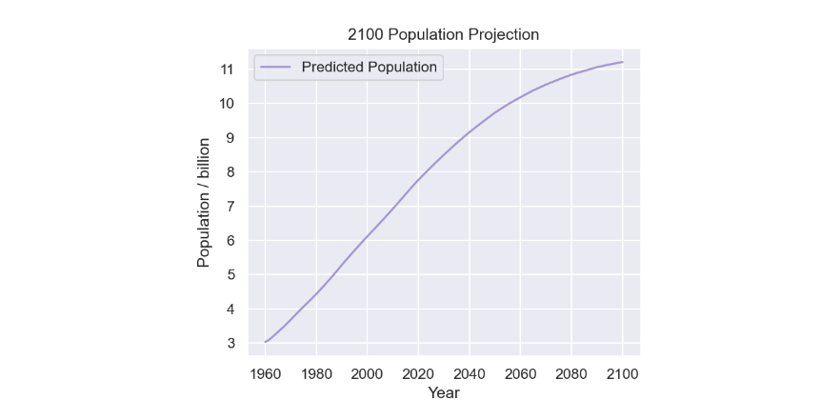 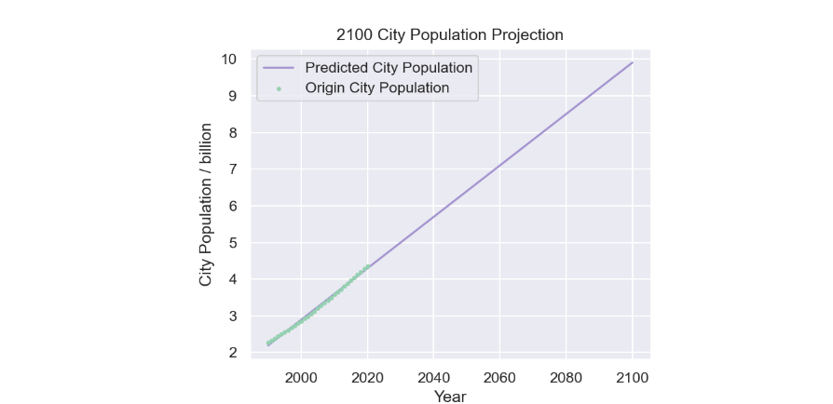

Selection: Global population, represented by the variable X, represents the total amount of CO2 emitted from human breathing and related emissions, including livestock breathing, industrial emissions and transportation emissions. In industrialized regions where the majority of CO2 emissions other than biological metabolism take place, various sources of CO2 emission in urban areas, including industrial emissions and wastes from petrol-powered vehicles, are combined into the variable Y, because population is directly connected to the size, affluence and ownership of CO2-producing machineries. Thus, the total quantum of CO2 emitted from these resources are represented with relatively high integrity.

Justifications: On global population, we referred to the data provided by UN Population Division[1]. Throughout the past five decades, economic globalization greatly promoted fertility and life expectancy, resulting in a stable increase in population. While underdeveloped regions are experiencing baby-booms, the current of sub-replacement fertility and aging of population have emerged in developed countries. Apparently, these changes have shown traces of acceleration, only to be diluted by the sharp rise of third-world population. Nevertheless, with the infiltration of capitals into developing economies in the coming decades, similar trends of decrease in population are expected to appear and cause the global drop in annual population growth to accelerate.

At the same time, however, urbanization unavoidably attracts younger generations to move into cities. By applying Linear Regression to the data from World Bank, we came to a curve that demonstrates the steady rise of urban population due to continual constructions and development of cities, especially in underdeveloped areas. (Reason), this method (advantage).

3.2.2 Forest Area and Farming Area Projection

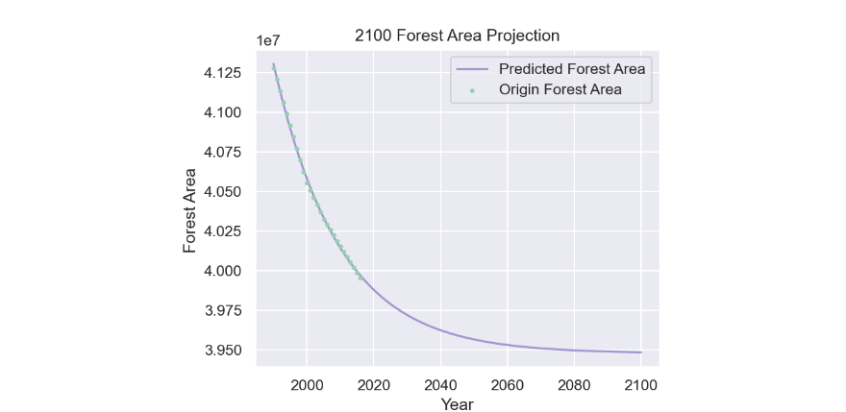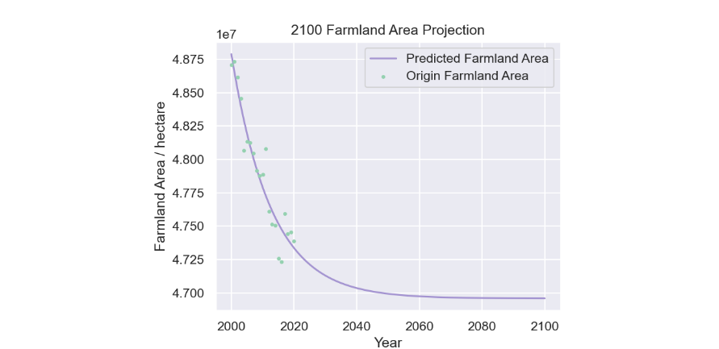

Selection: According to a 2014 NASA report, boreal and tropical forests absorbed a total of 2.5 billion metric tons of carbon dioxide that year[2]. Through photosynthesis, plantations in forest areas contributes more to the absorption of CO2 concentration in the atmosphere than any artificial or natural approach. Moreover, the vast area that forest covers and high efficiency of photosynthesis produces multiple effect on CO2 levels. Hence, changes in forest areas play an important role in the reduction of CO2 in the atmosphere. In contrast, farmlands bear less diversity in plant species, but they typically locate closer to cities where the density of CO2 are? times higher than that in the forest. Nearby farmlands around industrialized urban areas act as buffer belts for CO2 to further diffuse into the atmosphere, so they should be given equal importance with forests.

Justifications: Based upon the data, we chose exponential attenuation to model of forest and farming areas from year 2000 to 2100. As time passes by, the rates by which forest and farming areas decrease also goes down, which follows the exponential attenuation distribution. Hence, the resulting curves bear close resemblance to reality. Obviously, past researches and news mourning the loss of forest across the Internet continuously inform us about the sharp decrease in forest areas. Owing to rising public awareness and advanced policies, environmental protection from the past decade has exerted growing resistance on the drop of green areas. The dropping rate of forest loss confirms with our prediction as well. As farming technology keeps evolving in productivity and international organizations spreading advanced techniques to barren regions, less farmland is required to satisfy the need for crops. After certain productivity is reached, farming areas are supposed to stay stable until 2100.

3.2.3 Global GDP, Industry Added Value, Agricultural Added Value and GDP /petroleum Projection

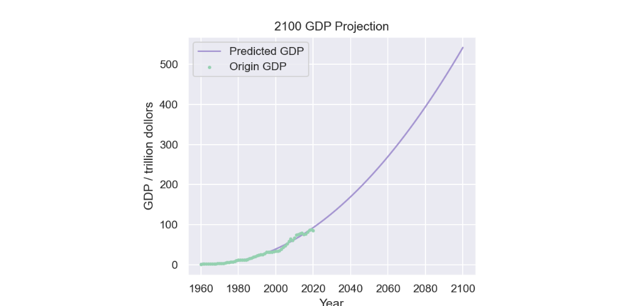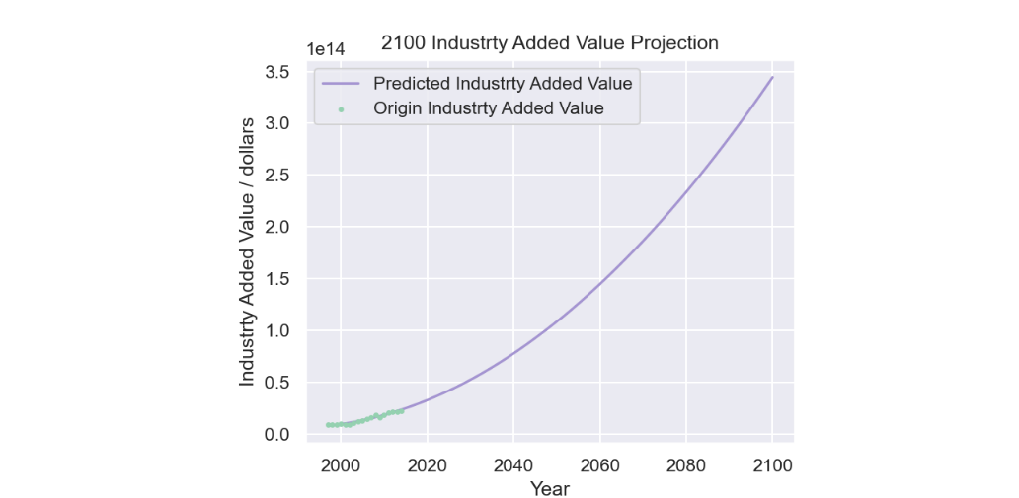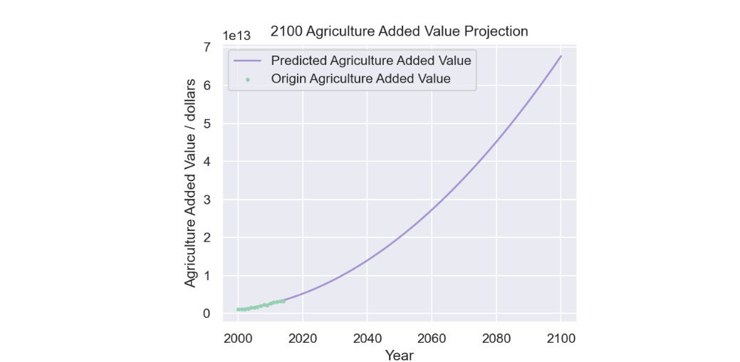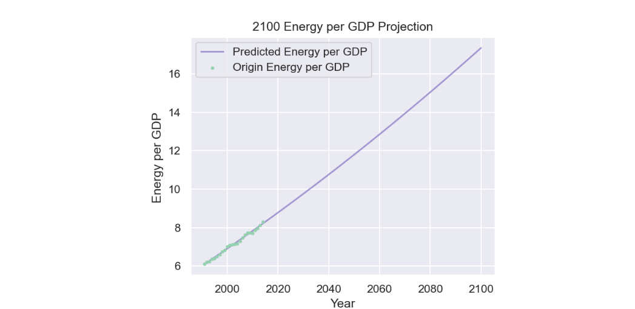

Selection: Originally, involving numerous industrial chains that go across thousands of industries, the wide range of emitting sources are nearly countless. To generate them, we selected four factors to show the frequency and quantity that goods and service are traded across the world, mainly in industrial and agricultural aspects. Behind these trades is CO2 emissions in production, transportation and utility. By involving these statistics into consideration, we are able to include as much sources of CO2 as possible, widening the scope of analysis while previous factors provide depth into key aspects. Specially, we chose the value of GDP/petroleum to better visualize the consequent CO2 levels produced by the processes behind these numbers.

Justification: Despite slight fluctuations from time to time, Global GDP, Industry Added Value, Agricultural Added Value have all been growing with global economy in general until 2022. We used Method 4 to optimize the congruence between the curve and historical records. With the development of technology, global economy will undoubtedly grow with increasing speed. It is worth noting that major contributors to economy growth will switch from clean energy-based developing countries to petrol-powered developing countries, so the value of GDP per petroleum is expected to rise.

3.2.4 Energy Production Projection

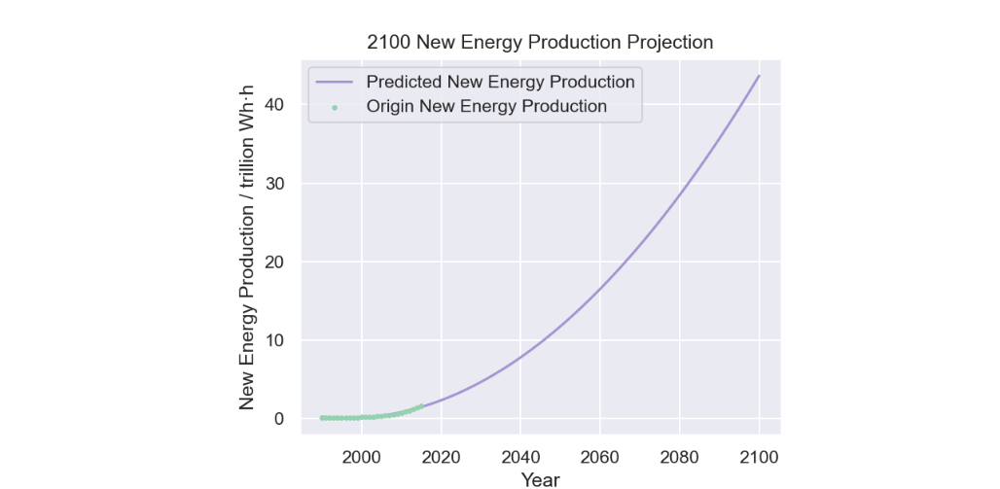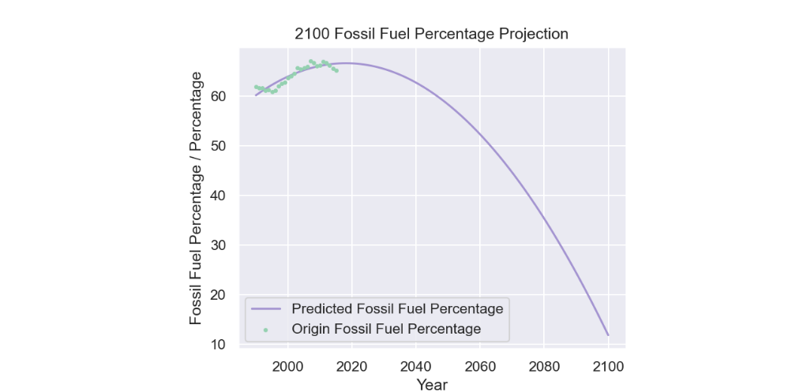

Selection: Traditional industrial production makes up a major part of CO2 artificial release into the atmosphere. On the other hand, unlike production burning fossil fuel for energy, industrial activities using certain new forms of energy are considered carbon-free and thus greatly reducing CO2 levels. Although the construction of power generating infrastructures produces CO2, new resources make considerable contributions in the long run. Wind, hydro and solar power and biomethane are typical renewable carbon-free energies. Certain unrenewable energies like nuclear energy also strictly limits carbon footprint in the extraction process previous to the power generation itself.

Justification: From a global point of view, power generation is currently at the dawn of carbon-free energies’ prevalence. Renewable energies are generally passing experimental stage and entering the power market in certain areas. With the help from subsidies and customers’ support, when inconvenience is overcome by developing technology and prices finally reach the point when fossil fuel and carbon-free energies possess equal strength in competition, petroleum will expose its weakness in limited storage and loose its users to new resources. Ultimately, carbon-free resources will replace fossil fuel and steadily grow in market shares and production percentage, as we predicted using quadratic functions, which records this competition with close accuracy.

3.3 Model 1

As mentioned above, we have picked ten representative factors for CO2 concentration c. Assuming c be represented as the linear combination of the ten variables, CO2 concentration will be calculated by the formula below.

c =

in which $\mathcf{k}_x$ and $\mathbf{x}$ are vectors respectively represent the weight of factors and the value of factors.

3.4 Model 2

3.5 Model 3

- Model predicting co2 concentration

- overall work flow

- single variable projection

- Model 1:

- **Principal components analysis**

- Multi-variable Linear Regression

- Model 2:

- stepwise regression

- STI model

- Model 3:

- ODE

- situations analysis

- Model predicting global tempreture

1. 联合国人口数据来源？
2. https://www.nasa.gov/jpl/nasa-finds-good-news-on-forests-and-carbon-dioxide